|  |  |  |
| --- | --- | --- |
| **Report IDM reference No.** | *EFDA_D_2MFY5M* | **Version: see IDM** |

Final Report

on Deliverable

*MAT-1.3.1-T3-D1 Status Report on Development of Rules for Brittle Fracture (KIT)*

|  |  |  |  |
| --- | --- | --- | --- |
|  | | **Deliverable-ID**[1] | *MAT-1.3.1-T3-D1* |
| **Work Package** | *WPMAT* | **Date** | *31.Oct.. 2015* |
| **Project Leader** | *Michael Rieth* | | |
|  | | | |
| **TS Title** | *EDDI Structural Design Criteria – Priority Gaps – Brittle Fracture* | | |
| **TS Ref. No.** | *EDDI-1.3.1-T03* | **TS IDM-link** | *EFDA_D_2KXPEY* |
| **Task Owner** | *Jarir Aktaa* | | |
| **RU(s)** | *KIT* | | |

|  |  |
| --- | --- |
| **Report Review & Approval** | |
| **IDM role** | **Name(s)** |
| **Author** | *Marco Conte* |
| **Co-author(s)** | *Jarir Aktaa* |
| **Reviewer(s)** | *Manminder Kalsey, Mike Gorley* |
| **PMU Reviewer** | *Eberhard Diegele* |
| **Approver** | *Michael Rieth* |

|  |  |  |  |  |  |
| --- | --- | --- | --- | --- | --- |
| x | Study / Assessment |  | Procurement / Commissioning of Hardware |  | Industry |

|  |  |  |  |
| --- | --- | --- | --- |
|  | Use of Facility |  | Other *{please specify}* |

|  |
| --- |
| **Executive Summary** |
| Complementary fracture mechanical experiments as well as bending tests supporting modelling of the observed fracture behaviour of tungsten alloys particularly in the brittle regime have been elaborated and described. In addition a short overview of the numerical simulation of crack propagation using the Cohesive Zone Model has been given. |

|  |
| --- |
| **Comments** (shortcomings, deviations, etc.) |
|  |

**Table of Contents**

1 Short Introduction and Objectives of Work 2

2 Description of Work 3

2.1 Experiments and Material 3

2.2 Cohesive Zone Model 7

2.3 Irradiation experiments 10

3 Conclusion 10

4 References 11

**Abbreviations**

|  |  |
| --- | --- |
| W | Tungsten |
| WL10 | Tungsten with 1wt. % La2O3 |
| 3PB / 4PB | Three-point bending test / Four-point bending test |
| DBTT | Ductile-brittle-transition-temperature |
| EDM | Electrical discharge machining |

# Short Introduction and Objectives of Work

The use of tungsten and tungsten alloys as armour and structural material require material design data base and rules in the entire temperature range of applications which is – up to now - not enough to describe the mechanical behaviour sufficiently. Especially at temperatures below DBTT literature data show a large scatter [1]–[3]. The main influences on strength and fracture toughness are anisotropy [2], loading rate [4] and degree of deformation [5]. Therefore mechanical test specimens of different size, shape and orientation of the global applied loading to the grain orientation are mandatory.

The task in 2015 includes:

* Planning, performing and evaluating of complementary fracture mechanical experiments as well as tests supporting modelling of the observed fracture behaviour particularly in the brittle regime.
* Starting the development of a suitable damage model for describing and simulating the fracture process observed in fracture mechanical tests considering specific aspects, e.g. anisotropy.
* Propose proper irradiation experiments on EUROFUSION baseline materials (e.g. from CuCrZr, EUROFER97, W/W alloys) for taking irradiation effects into account.

# Description of Work

## Experiments and Material

In this work the mechanical behavior of two different tungsten materials (pure W and WL10) and tungsten in two different semi-finished conditions are investigated. Both tungsten materials were fabricated by Plansee Metall GmbH, Reutte /Austria through the powder metallurgic route with sintering and a subsequent cold/hot working process. The material was delivered as a rod with 20 mm diameter (W, WL10) and a plate with 5 mm thickness (W). Both semi-finished products exhibit a distinct texture and anisotropy related to the rolling direction [2].

Beside four point bending test for characterizing the strength fracture mechanical test for toughness characterization are planned. All specimens are cut by electrical discharge machining (EDM) and grinded. In case of the bending specimens the specimens are polished in addition. The wire EDM process causes surface cracks with depths of up to 200 µm dependent on the microstructure [6]. Therefore a brief grinding and polishing process to reduce the machining influences is mandatory. Especially the bending specimens need a crack free surface to obtain reliable strength data and Weibull parameter [7]

To account for the anisotropic microstructure three specimens types (L-R, R-L, (C-R)) are investigated in case of rod material and two specimen types (L-S, T-S) in case of the plate material [8]. The transverse specimen types (R-L, C-R) cannot be cut out in a whole because of the limited rod diameter. The three investigated orientations are shown in Figure 1. Hence two extension arms with longitudinal orientation are soldered on the transverse part. The production of the specimens with the transverse orientations is illustrated in Figure 2. This method had been applied successfully for fracture toughness tests of polycrystalline tungsten [2], [3] and for single crystal tungsten [9].

 

Figure 1: Illustrations of crack orientation and texture of the investigated specimens made out of rod and plate material.



Figure 2: Illustration of the production of transverse (T) specimens with brazed longitudinal (L) extension arms.

Beside tungsten based alloys Eurofer and CuCrZr are considered as EUROfusion baseline materials for the application in fission reactors. Both materials show an embrittlement after irradiation which leads to an increase in the intrinsic scatter of the mechanical properties. Therefore the probabilistic approach, considered and further developed in this project, may also be applied to these materials in the brittle regime and lower shelf, respectively.

**Four point bending (4PB) test**

The determination of comparable tensile strength data for tungsten is difficult due to the brittleness of the material. Hence the 4PB test is more suitable to evaluate reliable flexural strength σf and flexural strain εf for brittle materials with less scatter caused by poor specimen alignment. The bending tests are performed in deformation control based on the standard ASTM C1161-13 with rectangular beams [10] in the temperature range of 300K – 525K. Table 1 shows an overview of the design of experiments for mechanical characterization. The bending test will be conducted with 30 specimens for each semi-finished product and testing condition.

Table 1: An overview of the 4PB tests in this work.

|  |  |  |  |
| --- | --- | --- | --- |
| 4PB [7] | W | | WL10 |
| semi-finished product | rod | plate | rod |
| orientation[8] | L-R, C-R, R-L | L-S, T-S | L-R, C-R, R-L |
| specimen size [mm] | 3 x 4 x 45 // 1,5 x 2 x 25 | | |
| test temperatures [K] | RT < T < 525 | | |

The load span is 20 mm and 10 mm and the support span 40 mm and 20 mm, respectively. The 4PB specimens for all orientations are produced in the same manner like the fracture mechanical ones. Thus the brazing layers in case of the transverse orientations (C-R, R-L) using 3 x 4 x 45 mm specimens are within the area of the highest moment of the 4PB loading device. This may lead to a premature fracture within the brazing layers. Figure 3 shows the bending moment diagrams with rectangular bending specimens (3 x 4 x 27 mm, 40 mm support span) for 4PB and 3PB, respectively. Upon comparison of the bending tests with brazed and unbrazed longitudinal specimens the size of the bending specimens have to be reduced for preventing premature fracture within the brazing layers. The influence of the brazing layers will be tested with bending tests of unbrazed and brazed specimens of all orientations.

$$\frac{ F }{2}$$

$$\frac{ F }{2}$$

$$\frac{ F }{2}$$

$$\frac{ F }{2}$$

$$\frac{ F }{2}$$

$$\frac{ F }{2}$$

$$F$$

$$M$$

$$M$$

(a)

(b)

**L**

**L**

**L**

**L**

**T**

**T**

Figure 3: Position of the brazing layers within the bending specimen and the associated bending moment diagrams of the 4PB test (a) and 3PB test (b).

The aim of the 4PB test is to provide bending strength data and material specific Weibull parameter $m$ and $σ_{0}$ for the probabilistic failure analysis as a function of orientation and temperature. $σ_{0}$ is the normalised strength with respect to the unit volume *V0* and can be extracted from the size-dependent Weibull scale parameter $b$ obtained for arbitrary specimen geometries. The Weibull parameter $m$ is the shape parameter and a measure for the scatter of strength data. The wider the distribution is, the smaller $m$. The probabilistic approach based on the weakest link theory by Weibull has been introduced in [11]. Failure probabilities of divertor components made of pure W and WL10 have been determined in [12] and [13].

**Fracture mechanical test**

The fracture mechanical tests are conducted with rectangular SENB specimens with outer dimensions of 4 x 3 x 27 mm3 and with a 1 mm deep U type notch [8] and [14]. The tests are performed in displacement control at a fixed loading rate of 1 µm/s and with the same specimen orientations as the 4PB test. Due to the size limitation of the plate, only miniaturized bend specimens can be used to investigate all orientations in both semi-finished products. The notch is produced by wire EDM and the pre-crack by polishing the notch with a razor blade and abrasives [15].The 3PB tests will be performed at the same temperatures like the 4PB test with additional test at temperatures complementary to the results published in [4]. Table 2 shows an overview of the experiments for fracture mechanical characterization. Fracture mechanical tests will be conducted with 5 specimens for each semi-finished product and testing condition.

Table : An overview of the fracture mechanical tests in this work.

|  |  |  |  |
| --- | --- | --- | --- |
| 3PB [8] | W | | WL10 |
| semi-finished product | rod | plate | rod |
| orientation[8] | L-R, C-R, R-L | L-S, T-S | L-R, C-R, R-L |
| specimen size [mm] | 4 x 3 x 27 | | |
| test temperatures [K] | RT < T < 525 | | |

## Cohesive Zone Model (CZM)

Numerical simulation of crack growth and fracture behaviour of engineering materials and structures can be phenomenological described with the cohesive zone model. The fracture process and the material separation only exist in a small zone – the cohesive zone - ahead of the crack tip. In contrast the surrounding area consists of damage-free continuum elements, which are only subject elastic-(plastic) deformation under global loading. Consequently failure occurs only along existing interface elements within the cohesive elements.

The cohesive zone model was first introduced by Dugdale (1960) [16] and Barenblatt (1962) [17] in a so called “strip-yield” model based on the idea to avoid the Griffith`s stress singularity at the crack tip. Thereby the crack system is divided into two parts. A stress free sector ahead of the crack tip and a define stress distribution at the crack tip. The magnitude of the stress at the crack tip is therefore limited to a constant stress equal to the yield strength $σ_{0}$ (Dugdale) or a stress distribution $σ(x)$ depending on the separation subjected to the process zone ahead of the crack tip (Barenblatt). In contrast the surrounding area consists of damage-free continuum elements, which are only subject elastic-(plastic) deformation under global loading. Consequently failure occurs only along existing interface elements within the cohesive elements.

The concentration of deformation in a discrete plane in the process zone is described by a constitutive equation, called traction-separation laws (TSL), which is identified by determining it material depended parameters.

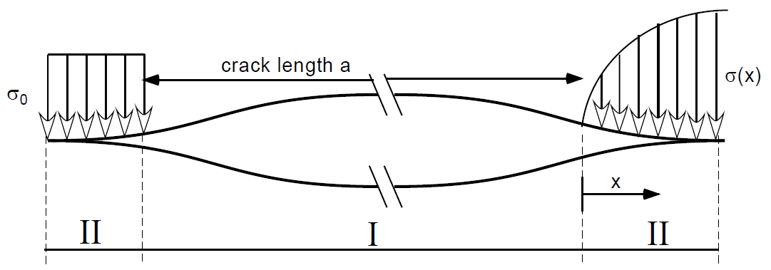

II

III

Figure : I stress free sector, II Dugdale model and III Barenblatt model.

Later on further fracture mechanical FEM studies with cohesive zone model with different TSLs have been developed by Carpinteri [18] and Hillerborg et al [19] for (quasi) brittle metals and Tvergaard and Hutchinson [20], Needleman [21] and Scheider [22] for mostly ductile metals (s. Figure 5).

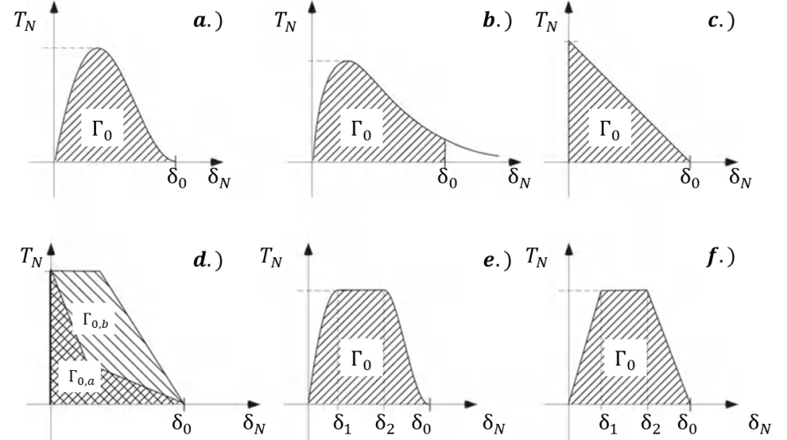

Figure 5: Typical traction-separation-laws for either (quasi) brittle (c [19] , d [23] )   
or ductile materials (a [21] ,b [24], e )[22].

For the determination of a (semi) brittle behaviour of tungsten alloys below the DBTT the TSLs by Needleman (b.) [24] or Scheider (e.) [22] can be applied.

**Traction-separation law**

The deformation and decohesion behaviour within a cohesive element is described by a traction-separation law (TSL). This law characterizes the relation between the traction $T$ and the separation $δ$ in a single cohesive element. Failure of a cohesive element occurs at a critical separation $δ_{0}$ after reaching the maximum stress, the cohesive strength ${ T}_{0}$. $T_{0}$ can be identified by uniaxial tensile test or by bending test with unnotched bending specimens, where $T_{0}$ correlate to the outer-fibre stress of the bending specimen. The third material parameter is the cohesive energy $Г_{0}$, which can be calculated by

$$Г_{0}= \int_{0}^{δ_{0}}{T\left(δ\right)dδ}$$

$Г_{0}$ is the energy needed to create a new area of fracture surface due to the failure of one cohesive element. Traction-separation laws usually based on two independent parameters ( $T_{0}$ and $Г_{0}$), if the shape of the TSL is known. Figure 6 shows the approach of the parameter identification of a cohesive zone model.

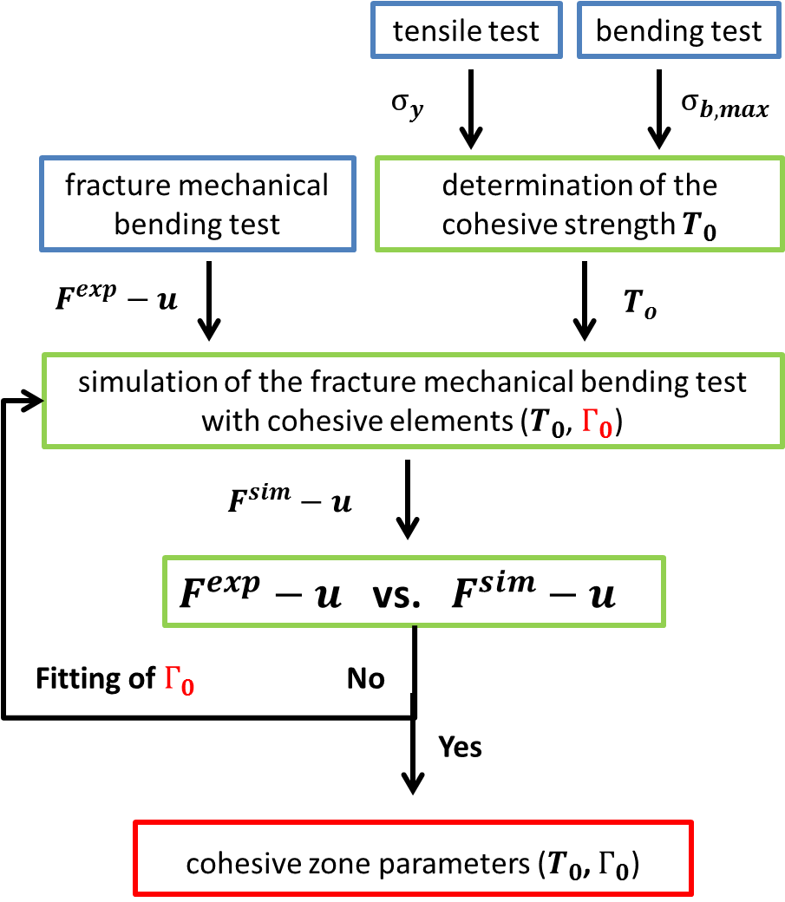

Figure 6: Identification of cohesive zone parameters.

The TSL by Scheider, shown in Figure 4, can describe brittle as well as ductile behaviour due to the variation of the additional shape parameters $δ_{1}$ and $δ_{2}$.



Figure 7: The cohesive law proposed by Scheider [22].

Mahler shows the applicability of this TSL in case of a ferritic-martensitic steel in the brittle and in the ductile regime below and above DBTT and its suitability to describe the fracture process observed in sub size and standard size specimens [25]. It has also been used by Bohnert to simulate the crack propagation and fracture toughness of single crystal tungsten on a micro scale [26].

According to [2] the specimens in C-R and R-L orientation have a mostly intergranular and flat fracture surface. Therefore the main crack propagation is along the plain of the notch root with less deflection. However the L-R orientation only shows transgranular fracture behaviour at temperatures below RT and changes it to intergranular at higher temperatures.

The identification of the cohesive parameters for the materials investigated here is planned and shall be executed when sufficient experimental force-deflection data of bending and fracture mechanical test are available.

## Irradiation experiments

Irradiation experiments have to be done to investigate the irradiation effects on tungsten alloys and other EUROFUSION baseline materials for the later long-term use in fusion reactors. Due to the high cost of irradiation and the problematic nuclear waste disposal the total specimen volume has to be as small as possible. However the size constraints for (fracture) mechanical test have to be fulfilled to get reliable results which are transferrable to regular component size and stress distribution. Especially the probabilistic failure analysis of brittle material with a common specimen numbers is not feasible within a irradiation program [7]. Therefore the extent of scatter of tungsten alloys dependent on temperature in the (semi) brittle regime, on texture and failure possibility due to specimen volume has to be investigating first on non-irradiation specimens sufficiently to suggest proper irradiation experiments. With the successful application of the probabilistic approach the number of specimens and orientations can be reduced. Afterwards irradiation experiments with smaller bending specimens, considering the influence of the specimen volume on the failure probability, can be conducted.

# Conclusion

The main tests for the mechanical characterization of tungsten alloys in the brittle regime have been described. 4PB testing of tungsten alloys provides strength data and Weibull parameter for further failure analysis and numerical simulation with suitable finite element code, e.g. Abaqus® and cohesive zone elements. To investigate the scatter dependent on the orientation of the texture to the applied load and temperature the number of specimen has to be large. However there is a delay in specimen production due to the large number of specimens. Furthermore this probabilistic approach should also be applicable to other brittle materials or materials with distinct irradiation embrittlement behaviour.

The numerical simulation of the crack propagation can be done with cohesive elements. The applicability of the TSL by Scheider [22] has been successfully demonstrated and it should be suitable describing crack propagation and failure in the brittle and semi brittle regimes of polycrystalline tungsten.

# References

[1] M. Faleschini, H. Kreuzer, D. Kiener, and R. Pippan, “Fracture toughness investigations of tungsten alloys and SPD tungsten alloys,” *J. Nucl. Mater.*, vol. 367–370, pp. 800–805, Aug. 2007.

[2] D. Rupp and S. M. Weygand, “Anisotropic fracture behaviour and brittle-to-ductile transition of polycrystalline tungsten,” *Philos. Mag.*, vol. 90, no. 30, pp. 4055–4069, Oct. 2010.

[3] R. W. Margevicius, J. Riedle, and P. Gumbsch, “Fracture toughness of polycrystalline tungsten under mode I and mixed mode I/II loading,” *Mater. Sci. Eng. A*, vol. 270, no. 2, pp. 197–209, Sep. 1999.

[4] D. Rupp and S. M. Weygand, “Loading rate dependence of the fracture toughness of polycrystalline tungsten,” *J. Nucl. Mater.*, vol. 417, pp. 477–480, Oct. 2011.

[5] J. Reiser, J. Hoffmann, U. Jäntsch, M. Klimenkov, S. Bonk, C. Bonnekoh, M. Rieth, A. Hoffmann, and T. Mrotzek, “Ductilisation of tungsten ( W ): On the shift of the brittle-to-ductile transition ( BDT ) to lower temperatures through cold rolling,” *Int. J. Refract. Met. Hard Mater.*, vol. 54, pp. 351–369, 2016.

[6] N. Holstein, W. Krauss, and J. Konys, “Development of novel tungsten processing technologies for electro-chemical machining (ECM) of plasma facing components,” *Fusion Eng. Des.*, vol. 86, no. 9–11, pp. 1611–1615, 2011.

[7] ASTM C1239-13, “Standard Practice for Reporting Uniaxial Strength Data and Estimating Weibull Distribution Parameters for Advanced Ceramics,” *Annu. B. ASTM Stand.*, pp. 1–17, 2000.

[8] ASTM E399-12, “Standard Test Method for Linear-Elastic Plane-Strain Fracture Toughness *KIc* of metallic materials,” *Annu. B. ASTM Stand.*, pp. 1–33, 2013.

[9] J. Riedle, P. Gumbsch, and H. Fischmeister, “Cleavage anisotropy in tungsten single crystals,” *Phys. Rev. Lett.*, vol. 76, no. 19, pp. 3594–3597, 1996.

[10] ASTM C1161-13, “Standard Test Method for Flexural Strength of Advanced Ceramics at Ambient,” *Annu. B. ASTM Stand.*, vol. 11, pp. 1–16, 2008.

[11] J. Aktaa, “Report for WP13-DTM-03-T05 – Development of DEMO SDC-IC – Structural Design Criteria for W / W alloys,” 2013.

[12] T. Weber, M. Härtelt, and J. Aktaa, “Considering brittleness of tungsten in failure analysis of helium-cooled divertor components with functionally graded tungsten/EUROFER97 joints,” *Eng. Fract. Mech.*, vol. 100, pp. 63–75, Mar. 2013.

[13] J.-H. You and I. Komarova, “Probabilistic failure analysis of a water-cooled tungsten divertor: Impact of embrittlement,” *J. Nucl. Mater.*, vol. 375, no. 3, pp. 283–289, Apr. 2008.

[14] H.-C. Schneider, J. Aktaa, and R. Rolli, “Small fracture toughness specimen for post-irradiation experiments,” *J. Nucl. Mater.*, vol. 367–370, pp. 599–602, Aug. 2007.

[15] T. Nishida, Y. Hanaki, T. Nojima, and G. Pezzotti, “Measurement of Rising R-Curve Behavior in Toughened Silicon Nitride by Stable Crack Propagation in Bending,” *J. Am. Ceram. Soc.*, vol. 78, no. 11, pp. 3113–3116, 1995.

[16] D. S. Dugdale, “Yielding of steel sheets containing slits,” *J. Mech. Phys. Solids*, vol. 8, pp. 100–104, 1960.

[17] G. I. Barenblatt, “The mathematical theory of equilibrium cracks formed in brittle fracture,” *Zhurnal Prikl. Mekhaniki i Tec.*, vol. 4, pp. 3–56, 1961.

[18] A. Carpinteri, B. Chiaia, and P. Cornetti, “A scale-invariant cohesive crack model for quasi-brittle materials,” *Eng. Fract. Mech.*, vol. 69, pp. 207–217, 2001.

[19] A. Hillerborg, M. Modéer, and P.-E. Petersson, “Analysis of crack formation and crack growth in concrete by means of fracture mechanics and finite elements,” *Cem. Concr. Res.*, vol. 6, no. 6, pp. 773–781, 1976.

[20] V. Tvergaard and J. W. Hutchinson, “The relation between crack growth resistance and fracture process parameters in elastic-plastic solids,” *J. Mech. Phys. Solids*, vol. 40, no. 6, pp. 1377–1397, 1992.

[21] A. Needleman, “A continuum model for void nucleation by inclusion debonding,” *J. Appl. Mech.*, vol. 54, no. 3, p. 525, 1987.

[22] I. Scheider, “Cohesive model for crack propagation analyses of structures with elastic – plastic material behavior,” *GKSS Res. center, Geesthacht*, pp. 1–41, 2001.

[23] Z. P. Bažant, “Concrete fracture models: Testing and practice,” *Eng. Fract. Mech.*, vol. 69, no. 2, pp. 165–205, 2001.

[24] A. Needleman, “An analysis of decohesion along an imperfect interface,” *Int. J. Fract.*, vol. 42, no. 1, pp. 21–40, 1990.

[25] M. Mahler and J. Aktaa, “Prediction of fracture toughness based on experiments with sub-size specimens in the brittle and ductile regimes,” *J. Nucl. Mater.*, pp. 1–8, 2015.

[26] C. Bohnert, S. M. Weygand, N. J. Schmitt, R. Schwaiger, and O. Kraft, “Investigation of the fracture behavior of tungsten at the micro scale,” in *International Conference on Fracture*, 2013, pp. 1–8.

1. One *Deliverable Report* shall be submitted for each deliverable e.g. Study Report, Commissioning Report, Final Assessment Report, Technical Acceptance Report, Procurement Report, etc.